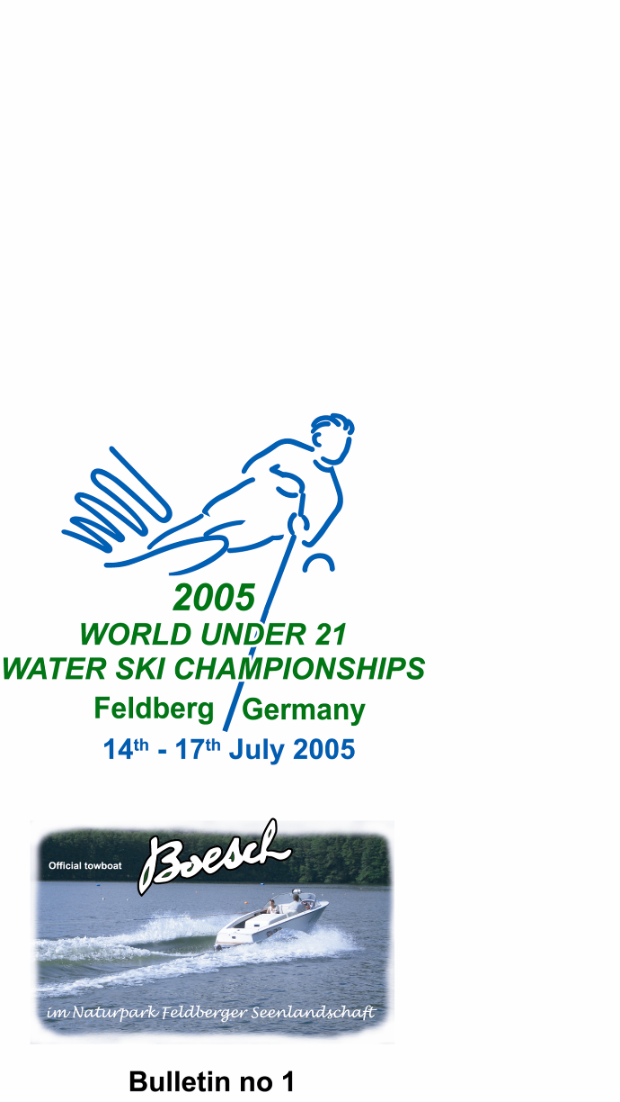


BULLETIN 2

Organiser
German Water Ski Federation and Wasserskiverband Mecklenburg Vorpommern.

Adress of the Organising Committee
Alfred Schipner, Fürstenberger Strasse 31, 17258 Feldberg / Germany
Phone: +49 39831 20592
Fax: +49 39831 20035
Email: mail@u21waterskiworlds.com
Homepage: www.u21waterskiworlds.com

Place of event
Feldberg is approximatly 120 km north-west of Berlin.
Bundesleitsungszentrum “Nord” Feldberger Hütte, 17259 Feldberg
Official training center of the German Water Ski Federation.

Area map
See our official homepage or go to this link:
http://www.viamichelin.com/viamichelin/gbr/dyn/controller/mapPerformPage?strReflex=142121&mapId=-.e6lrrlwue5wv&pim=true

Provisional Programme
Tuesday, 12th July Arrival of teams and officials -Accreditation
Wednesday, 13th July 09.00 Accreditation
14.00h Team Captains’ meeting
15.00h Jury meeting
17.00h Opening Ceremony
Thursday 14th July 08.00h Preliminary rounds
Friday, 15th July 08.00h Preliminary rounds
Saturday, 16th July 08.00h Preliminary rounds tricks
14.30h Finals
Sunday, 17th July 09.00h Finals
15.00h Medals presentation and Water ski show
19.00h Closing Banquet
Monday, 18th July Departure

A more detailed competition schedule will be published soon on the official homepage.

Intention to compete
The following countries have announced their participation until today: Austria, Australia, Belarus, Belgium, Canada, Chile, Colombia, Croatia, Cyprus, Czech Republic, Denmark, Finland, France, Germany, Great Britain, Greece, Italy, Luxembourg, Mexico, New Zealand, Poland, Sweden, Spain, Switzerland, USA

Each Federation shall certify to the Chairman of the World Tournament Council and the organising committee not later than 13th May 2005 its intent to compete. Any Federation not meeting this requirement will not be allowed to compete until they pay a fine of 200 Swiss Francs to the IWSF.

Official entry forms
The official entry forms for teams and individuals are enclosed. This form must be sent to the Chairman of the World Tournament Council, Mr. Bob Corson and to the German Water Ski Federation before July 3, 2005. For late entries a fine of CHF 10.00 per day and skier as per Rule 2.05 will apply.

INDIVIDUAL ENTRIES
Skiers not selected for their national teams may qualify to compete in the U21 World Championships if they are ranked on the IWSF World Rankings List in the top four (4) of those qualified by age in any event including overall. Tournaments held on the weekend of April 30-May 1, 2005 will be included in the Ranking List that covers the period from May 1, 2004 to April 30, 2005. This list will be used for Individual Qualification for the U21 World Championships.

Hotels/Accommodation
All prices include continental breakfast.

As announced in Bulletin 1 the reservation deadline for the Feldberg accommodations was March 31, 2005. There are still a few rooms available. Otherwise you have to book your rooms at the Hotel Radisson SAS in Neubrandenburg. Deadline for this hotel is May 31. Please mention “Waterski” with your reservation.

Seehotel Feldberg *** in Feldberg ( 29 rooms) – Official hotel - full
Phone +49(0)39831 555 fax +49(0)39831 55600
Cost: Double room EURO 72,-- ,single room EURO 46,--

Hotel Stieglitzenkrug (***) in Feldberg (21 rooms, 4 bungalows).
Phone +49 (0) 39831 20420, fax +49(0) 39831 20374.
Double room EURO 72.--, single room EURO 70.--.
Bungalow for 4 persons EURO 120.--.

Hotel Zollhaus *** in Feldberg (20 rooms).
Phone +49(0)39831 500, fax +49(0)39831 50222.
Double room EURO 87.--, single room EURO 70.--.
Guesthouse ** in Feldberg
Phone +49(0)39831 500, fax +49(0)39831 50222.
Double room EURO 66.--, single room EURO 40.--.

Youth Hostel in Feldberg
Phone +49 (0) 39831 20520, fax +49(0) 39831 .
Per person EURO 15.--,

Hotel Radisson SAS *** Neubrandenburg (120 rooms )This Hotel is 30 km from Feldberg.
Phone +49(0)395 5586621, fax +49(0)395 5586625
Double room EURO 74.--, single room EURO 72.--.
Triple room EURO 76,--

Credit Cards
All major credit cards are accepted. (No American Express credit cards)

Transport from Berlin
The nearest international airports are Berlin Tegel and Berlin Tempelhof. Transport for teams can be arranged at with a common bus at EUR 30.00 per person. Please use the attached form to request transport. Deadline is June 30.

Rent a Car
All major rental car companies are represented at both airports.

Official towboat
The official towboat will be the BOESCH 560 Competition Skiboat equipped with Perfect Pass.

Official jump measuring system
The BOETTCHER system will be for jumping.

Entry fee
The entry fees are sponsored by BOESCH Motorboat Company on the occasion of the 20th BOESCH CUP.

VISA
Please check Visa requirements with the German Embassy in your Country. Should you need assistance please contact us on.
Phone +49(0)395 421 16161
Fax +49(0)39831 20035
Email: mail@u21waterskiworlds.com

Antidoping Control
As per IWSF and WADA rules.

Training
Training will be available on the official competition site from July 11 to July 13. The costs are EUR 220,00 per hour. Training times will be allocated on a first come first serve basis and are limited to 20 minutes per skier or total 150 minutes per Team.

For interested Federations special arrangements for training camps can be made from May 1 until July 9. The following dates are still available: 02.05.-13.05., 23.05.-05.06. and
13.06.-26.06.

All trainings must be booked before June 24 through the Organising Committee.
Email: mail@u21waterskiworlds.com

The training booking list will be published in Bulletin 3.

We look forward with great pleasure to welcome you in Germany.

Your

U21 WORLD CHAMPIONSHIPS ORGANISING COMMITTEE

